**POST GRADUATE GOVERNMENT COLLEGE, SECTOR 11, CHANDIGARH**



PRACTICAL FILE

OF

MAJOR PROJECT

**BCA-16-603**

**SUBMITTED TO : SUBMITTED BY:**

Dr. PUNEET MODGIL PURNIMA SINGH

BCA 6 SEM

4301/18

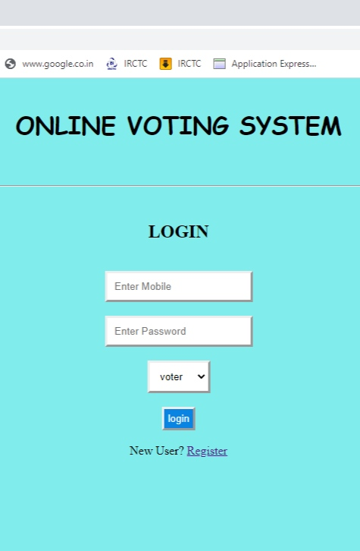 HOMEPAGE OF ONLINE VOTING SYSTEM

If not , Register first by clicking on (register )

Login your Account , if you are registered .

REGISTRATION PAGE !!!!!!

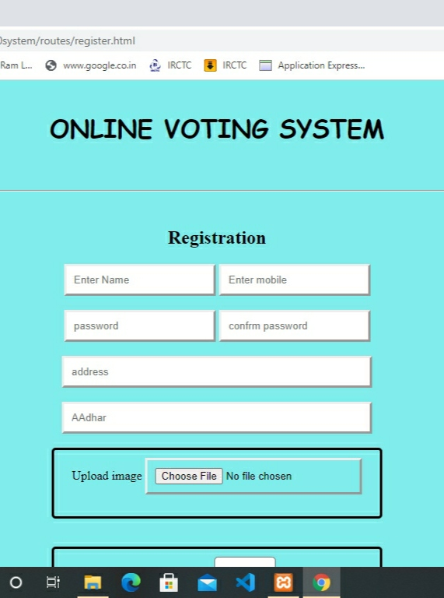

FILL THE INFORMATION ,

UPLOAD PROFILE PICTURE.

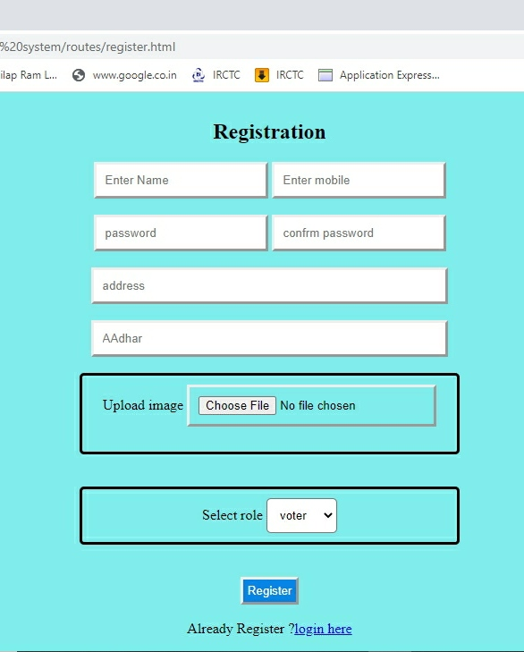

SELECT THE ROLE , IF YOU ARE A SINGLE VOTER OR

THE GROUP WHICH IS ELECTED

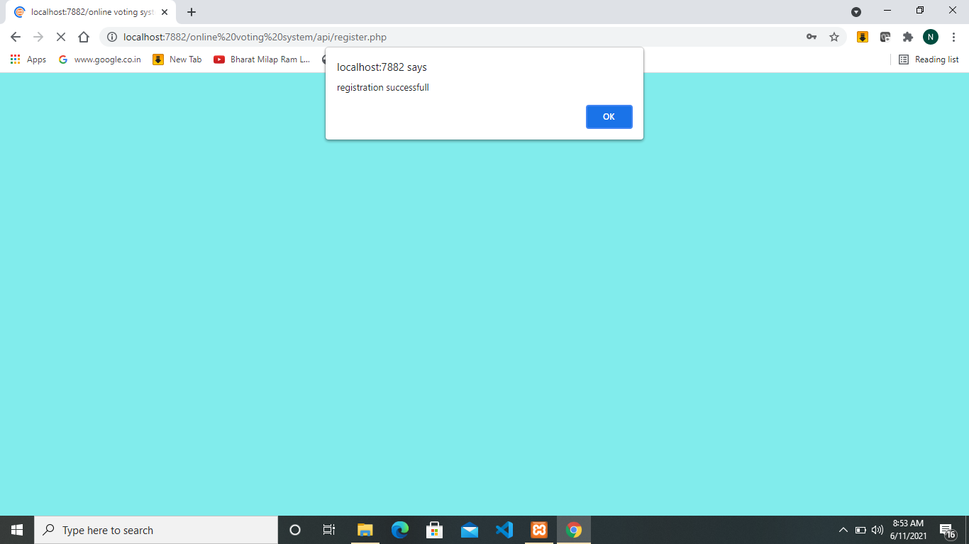

AFTER YOU REGISTER YOURSELF BY CLICKING ON THE REGISTER BUTTON

YOU WILL GET A POP UP OF

(REGISTRATION SUCCESSFUL)

AND BRING YOU BACK TO THE LOGIN PAGE



LOGIN YOUR ACCOUNT TO VOTE

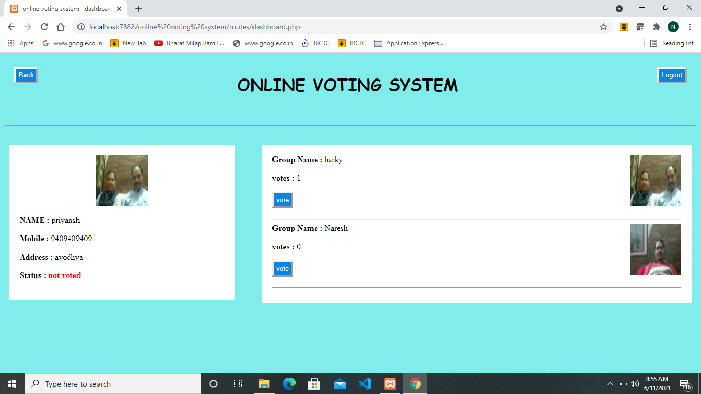

THIS PAGE WILL OPEN AFTER LOGIN , CLICK ON THE VOTE BUTTON UNDER THE GROUP NAME TO VOTE , STATUS IS NOT VOTED UNTILL YOU DONT VOT

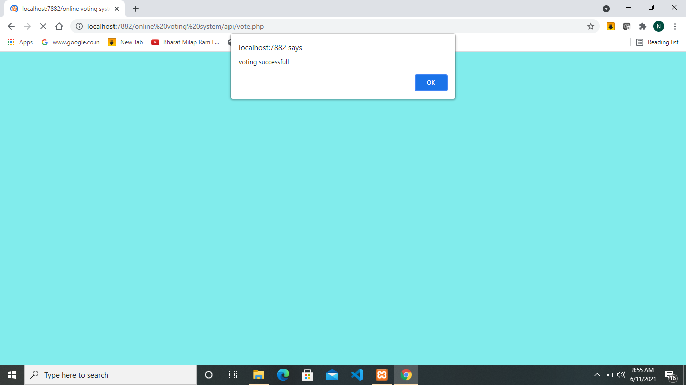

YOU WILL GET THE POP UP OF VOTING SUCCESSFUL, CLICKING ON OK YOU WILL BE BACK TO DASHBOARD.

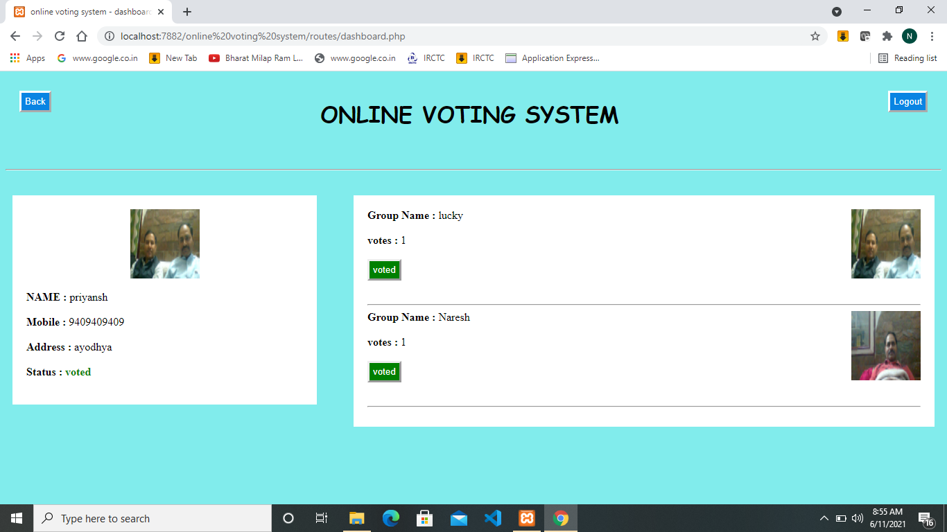

AFTER VOTING YOUR STATUS WILL CHANGE TO VOTED AND THE BUTTON BELOW THE GROUP NAME WILL GET GREEN (DISABLE ). CLICK ON LOGOUT BUTTON TO GO BACK TO LOGIN PAGE .